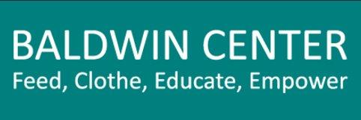
Volunteer Release Form
Today’s Date: ________________________

Name

Street Address Birthdate

City, State, Zip _______________________________________________ Cell Phone ______________________

Email ______________________________________________________ Group Affiliation__________________

Emergency Contact Phone

Liability Release: I hereby release, indemnity and hold harmless The Baldwin Center, Inc., the organizers, sponsors and supervisors of all its activities, from all liability in conjunction with the day’s events.

Signature Date

Communications Release: I hereby give to The Baldwin Center Inc., to its nominees, agents and assigns, my free and unlimited consent and permission, waiving all claims for any compensation by reason thereof or for damages by reason thereof, to use, publish, republish or exhibit in the furtherance of its work, with or without identification of me by name, the photographs, videos, or statements taken during today’s event and to disseminate statements referring to me in conjunction therewith if The Baldwin Center, Inc. so desires and to authorize any newspaper, company or other organization to use, publish, republish or exhibit said photograph with or without identification of me by name and to publish or disseminate statements referring to me in conjunction therewith in the promotion of The Baldwin Center, Inc. and any of its fund campaigns or any of its activities.

Signature Date

COVID-19 Vaccination Verification: I am fully vaccinated. I understand that “fully vaccinated” means 2 weeks after the second dose in a 2-dose vaccine series (e.g. Pfizer or Moderna) or 2 weeks after a single dose vaccine, (e.g., Johnson & Johnson) and a booster shot.

Vaccination Date___________________________________________Booster Date_________________________

Signature Date

Parental Consent/Release: If the individual is a minor (under 18 years of age), the following should be signed by a parent or legal guardian: I hereby consent and agree, individually, and as a parent or legal guardian of ______________________________ to all the terms and provisions above. I understand that my child/ward may be unsupervised for durations of time if project supervisors are needed elsewhere.

Signature____________________________________________ Date___________________________________

Name (Please Print) ____________________________________________________________________________

Address_________________________________________________ Relationship to minor__________________

